Implementation of automotive system reduce bandwidth usage in real time video system
B - 21
Ananth Dayakar Hegde, USN: 2SD18CS015., Email: ananthdayakarsdm@gmail.com, Mobile: +91 82773 94032
Ankit Anand, USN: 2SD18CS016, Email: ankit2024computer@gmail.com, Mobile:
+91 6205 066 814
S Varun, USN: 2SD18CS130, Email: varun3082000@gmail.com, Mobile: +91 94837 12819
Mohammed Usman E Gani, USN: 2SD18CS059, Email: ka.usmanegani@gmail.com, Mobile: +91 80886 11415

Dr. Umakant P Kulkarni, Email: upkulkarni@yahoo.com, Mobile: +91 94489 15301
Shri Dharmasthala Manjunatheshwara College of Engineering and Technology, Dharwad, Karnataka, India.

Abstract

The project is titled “Implementation of automotive system reduce bandwidth usage in real time video system”.

Wireless sensor networks (WSN) con nect small devices, each of which has its own sensing computation and communication components and power sources. The task of such networks which are distributed and adhoc is generally to monitor the environment and collect specific data such as temperature, pressure, and humidity. But such sensors generate a limited amount of information which can be insufficient for many applications even if large sensors are deployed. Hence the need arises for WSNs with multi-dimensional data sensors such as camera sensors to which are referred as visual sensor networks (VSNs). With recent advances in imaging technologies, producing small, low-power, low-cost image/video capture devices at a large scale may be within reach in the foreseeable future.

Thus, this project’s main aim is to reduce network traffic when using real time video

services such as video conferencing or surveillance. This can allow for businesses and people to reduce costs and lead a more sustainable and green economy even while using high energy services.

The project contains 2 main components, mainly, the client-side reconstruction library and the server-side differentiating and parsing engine. Both will be integrated into the final software.

Keywords

Wireless sensor networks (WSN), Visual sensor networks (VSNs).

Objectives

The objectives of the work are.
- To Understand the technologies to be used in the implementation of the project.
- Design of test bed (Virtual sandbox for experimentation) and optimization of the algorithm.
- Development of test bed, where the test bed is supposed to show all the clients that are currently connected to the particular room, while also providing basic metrics like latency, frame per sec, bandwidth saved.
- Development of image differentiating and reconstruction suites.
- On the server, the differentiating engine acts as a pre-processor, comparing the previous frame to the current frame and sending the differences and reconstructs the video. On the client side, the frame is then reconstructed based on the data received.
- Integration of above-mentioned backend and the frontend.

Outcomes

Following are the outcomes of the work carried.
- The team was able to develop a LMS software that was complete in functionality and test the prototype
- The team acquired new skills in the process, learning the XAMPP stack as well as dev ops tools like Git and Trello

Introduction

A Learning Management System (LMS) is a term used to describe software tools designed to manage user learning interventions. LMS is a web-based technology used to plan, implement and assess a specific learning process. LMS which is also referred as Course Management System (CMS) provides workspaces to facilitate information sharing and communication among students and lecturers to participate in course activities. Educators can distribute information to students, produce content material, prepare assignments and tests, engage in discussions, manage distance learning and enable collaborative learning using forums, chats and news services. Nowadays LMS are not restricted to distant uses. Nevertheless, the pedagogical expressiveness of designed courses is strongly dependent on the teacher’s knowledge and expertise about the targeted platform.

Literature Survey

Wireless sensor networks (WSNs) are an important research area that has attracted considerable attention. Most of this attention, however, has been concentrated on WSNs that collect scalar data such as temperature and vibration. Scalar data can be insufficient for many applications such as automated surveillance and traffic monitoring. In contrast, camera sensors collect visual data which are rich in information and hence offers tremendous potential when used in WSNs. But however, they raise new challenges such as the transmission of visual data with huge computational and bandwidth requirements in mainly low-power visual sensors networks. It is largely agreed on the following points of VSNs
1. Streaming all data is impractical due to server energy and bandwidth constraints
2. Processing cost is significantly lower than communications cost
3. It makes sense to reduce the size of data before sending
4. Visual data processing is computationally expensive
5. No easy answer to the question of how and where visual data should be managed
where -> at the node at Base station or at all
How -> compression, fusing and filtering, etc.
6. VSNs are focused on application goals.
7. Field of View (FOV) i.e., coverage, and connectivity are coupled issues.
8. Coverage optimization is more complex, but the optimization mechanism must have low complexity
9. It is challenging to design interaction and communication protocols.
10. Correlation of data among adjacent camera sensors is the major challenge.
11. Need for a algorithm that supports the requirements of bandwidth reduction over video streaming.
12. Reliability of sending data is crucial.

Methodology

1. An interface to capture images from a webcam, continuously and also extract selected frames for processing
2. Client-server model where multiple clients (WEBCAM) send data to the server for display (Continuous).
3. Measurement of Quality if the image at the server
4. Processing of image at server-side and integrating the algorithm to compare with previous frame captured and management of associated image accordingly.
5. Customer environment: Elegant User Interface for surveillance

Acknowledgement
The team would like to acknowledge the guide, Prof. UP Kulkarni for his unwavering support and wisdom in the field of development. The team would also like to thank the HoD of the Department of CSE, SDM College of Engineering and Technology, Dharwad Autonomous college affiliated to Visvesvaraya Technological University, Belagavi, Karnataka, India

References
[1] Node js
a. Socket Connection and for Multiclient
b. URL: [https://nodejs.org/en/]
[2] REACT:
a. A JavaScript library for building user interfaces
b. URL: [https://reactjs.org]
[3] OPENCV:
a. Open-Source Computer Vision Library for frame change detection
b. URL: [https://opencv.org/]

Bibliography

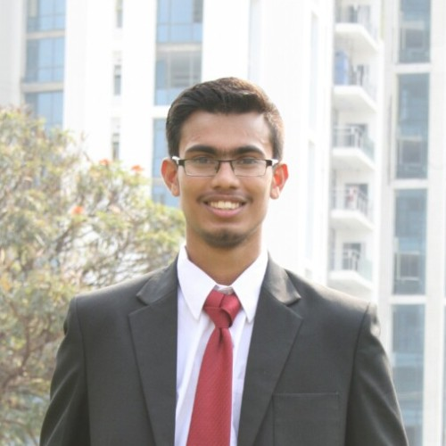Ananth Dayakar Hegde (USN: 2SD18CS015, B21 – 2018-2022)

Ananth Dayakar Hegde is a self-motivated web and app developer with a high level of experience working on multiple projects.
Across his 3 years in college, while maintaining a 9.0+ GPA, he also founded his own club that conducts workshops for the students in various application-level skills like web and app development. He is also the webmaster for the college student AMC chapter, and one of the founding members of the chapter. He has developed various projects for the college including but not limited to hostel management system, websites for various fests, and a CO PO Mapping Excel tool.

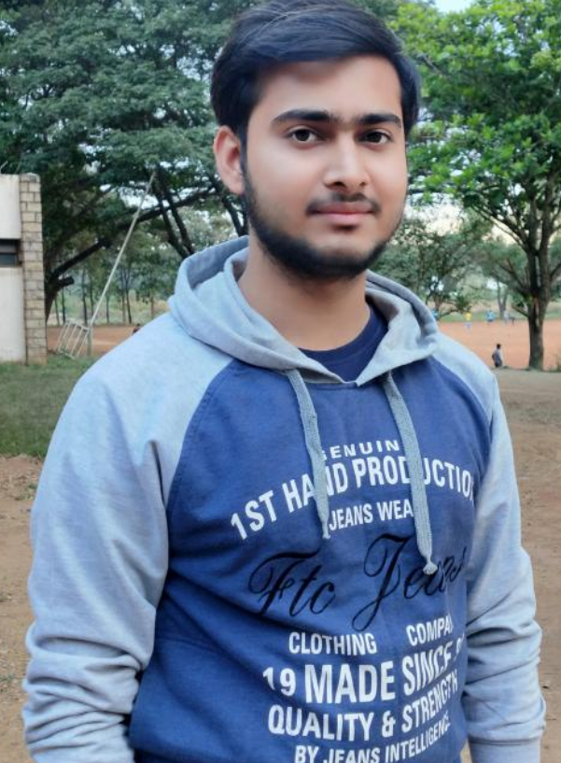Ankit Anand
(USN: 2SD18CS016, B21 – 2018-2022)

Ankit Anand is a motivated web developer with a good in experience working on multiple projects and serving the society with his initiatives.
Across his 3 years in college, while maintaining a 9.0+ GPA, he also been a part of the club that conducts workshops for the students in various application-level skills like web and app development.

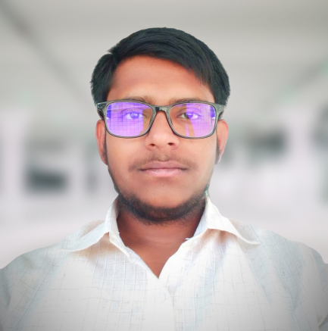Mohammed Usman E Gani (USN: 2SD18CS059, B21 – 2018-2022)

Mohammed Usman E Gani is a passionate web and app developer who specializes in flutter with a high level of experience working on multiple projects.
Across his 3 years in college, while maintaining a 8.5+ GPA, he also founded his own club that conducts workshops for the students in various application-level skills like web and app development. He is also a instructor at QWERTY.IO club where he teaches web Development. He has developed various projects for the college for various fests, and a CO PO Mapping Excel tool.

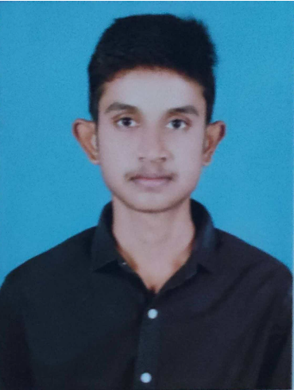S Varun
(USN: 2SD18CS130, B21 – 2018-2022)

S Varun web development and ML enthusiast with a good in experience working on multiple projects.
Across his 3 years in college, while maintaining a 9.0+ GPA, he also been a part of the club that conducts workshops for the students in various application-level skills like web and app development.

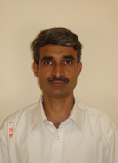Dr. Umakant P Kulkarni
Dr. Umakant P Kulkarni is a professor in the department of Computer Science & Engineering at SDM College of Engineering and Technology, Dharwad, Karnataka, INDIA.
He has obtained his Bachelor of Engineering (BE- CSE) in 1989 from Karnataka University, Master of Engineering (CSE) in 1991 from P.S.G College of Technology, Coimbatore and PhD from Shivaji University, Kolhapur. He has guided several U.G, P.G and PhD students. He has conducted several Workshops/training programs in the CSE domain and specifically in Outcome Based Education (OBE).
He has published several papers and obtained copyrights in the specific area of stream processing and OBE framework related work. He has completed one AICTE Funded project (9.5 Lacs). His area of interest includes Distributed Systems and Applications, Pervasive and Ubiquitous Computing, Software Agents and NBA/NAAC accreditation based on OBE framework. Presently he is coordinating NBA & IQAC activities at Institute level.

